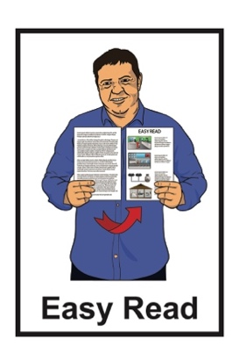

About the Telecommunications   
Dispute Resolution service

A picture of a woman using a computer and a man using a phone


Published: August 2024

# What you will find in here

**Page number:**



About this document 3



What is TDR? 6

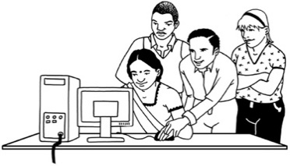

What does TDR do? 8



[What to do if you have a   
telecommunications complaint 9](#_What_to_do)

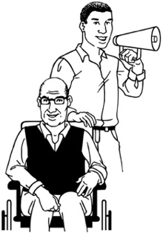

Who can TDR assist? 11

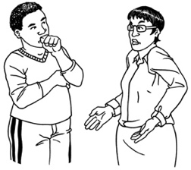

Who can TDR not assist? 13

**Page number:**

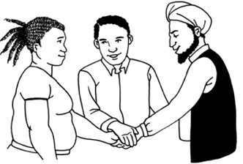

How will TDR assist you? 16



How to contact TDR 18



Where to find more information 21

# About this document

This Easy Read document is about the **Telecommunications Dispute Resolution** service.



**Telecommunications** means technology that helps you talk to others using things like:

your phone

the internet.



**Dispute** means when you have a problem you want to complain about.



**Resolution** means finding an outcome to a dispute that is fair for everyone.

The Telecommunications Dispute Resolution service is also called the TDR.



In this document we mean TDR when it says us / we.

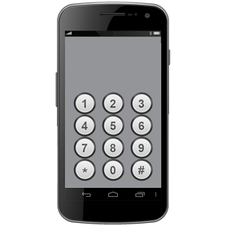

TDR is a service to assist people who have a **complaint** about their:

phone

internet.

You have a **complaint** when:

you have a problem

the problem is not being fixed in a way that you like

you want the problem to be fixed better.

This document is for people who:

have a complaint about their telecommunications

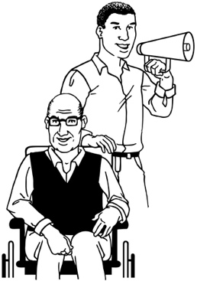are not happy with how the complaint is going

want assistance with the complaint.

# What is TDR?

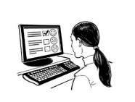

TDR is a service that assists people with telecommunications complaints.

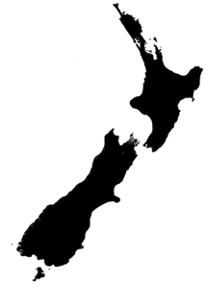

TDR assists people throughout Aotearoa New Zealand.

We can assist you with your telecommunications complaints by working with:

you

****your **telecommunications provider**.

Your **telecommunications provider** is a company that has a telecommunications service you use like your mobile phone company.

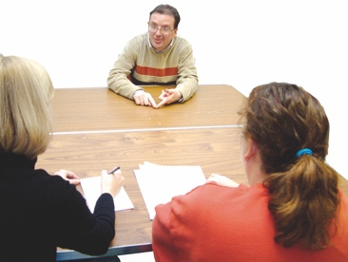TDR is an independent service which means that we are not controlled by anyone else.



TDR is free to use which means you do not need to give us any money.



We have been working with telecommunications complaints since 2007.

**2007**

# What does TDR do?



We can assist people in Aotearoa New Zealand with complaints they have about their:

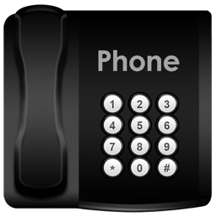internet

home phone

mobile phone.

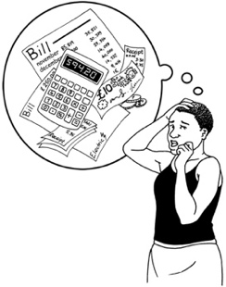We assist people with complaints like:

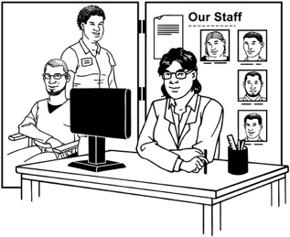understanding the bills people have been sent to pay

complaints about customer service

complaints about how telecommunications are working.

# What to do if you have a telecommunications complaint

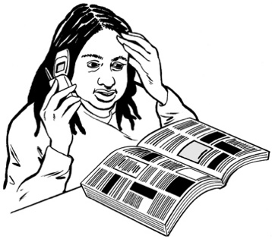

If you have a problem with your telecommunications the first thing to do is tell your telecommunications provider.



Your telecommunications provider should have the chance to fix the problem themselves first.



If you do not know how to tell your communications provider that you have a problem then TDR can help you.

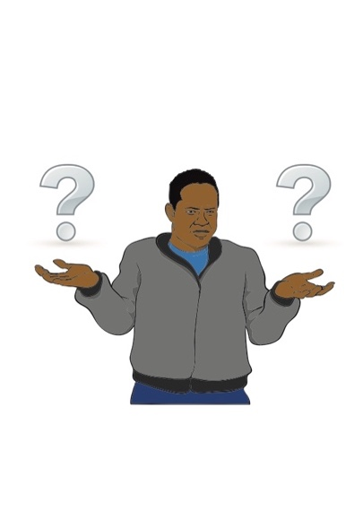

We can also help you if you do not know how to make a complaint to your telecommunications provider.

Usually your telecommunications provider can assist you.



Sometimes you may find that:

your telecommunications provider was not able to assist you

you did not like the outcome your telecommunications provider gave you.



You can talk to us at TDR if this happens.



We are able to support many people to get a good outcome for their complaints.

# Who can TDR assist?

We can assist with complaints about telecommunications providers who have signed up to our TDR service.



Almost all telecommunications providers in Aotearoa New Zealand have signed up to the TDR scheme.



This means that we are very likely to be able to assist you.



You can check if your telecommunications provider has signed up to the TDR scheme on our **website** at:

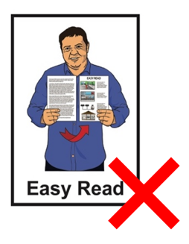

[**www.tdr.org.nz/about**](http://www.tdr.org.nz/about)

This website is **not** in Easy Read.

We can also assist with complaints about:

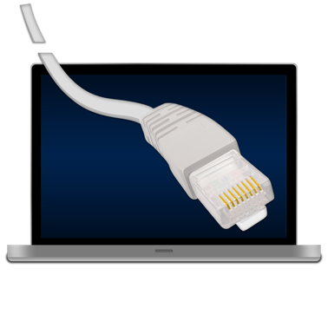being able to call 111 in an emergency

**copper services** being removed in your area.

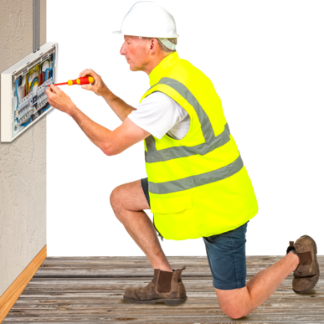**Copper services** means the older internet / phone cables.

In New Zealand these are being replaced with faster internet cables.

# Who can TDR not assist?



There are some complaints that we cannot assist with.



We cannot assist with complaints about **equipment** that did not come from your telecommunications provider.



**Equipment** means things you use your telecommunications service with such as your computer.

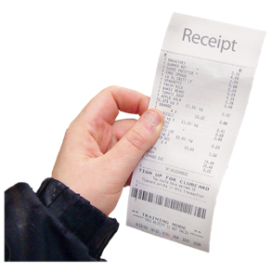For us to assist with equipment you must have:

bought it from your provider

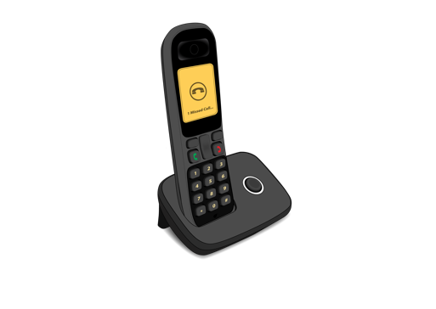

**or**

borrowed it from your provider.

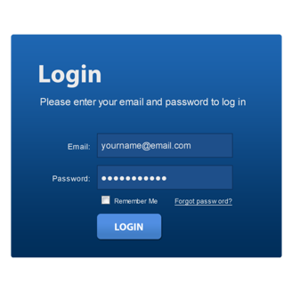We cannot assist with complaints about apps / downloads that did not come from your telecommunications provider.



For us to assist with   
apps / downloads you must have:

bought them from your provider

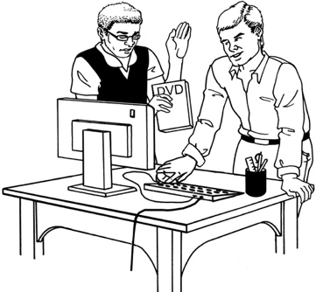

**or**

got them from your provider.

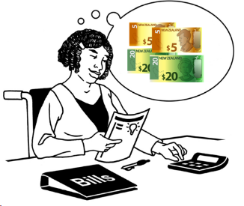

We cannot assist with utilities like:

* power / electricity
* 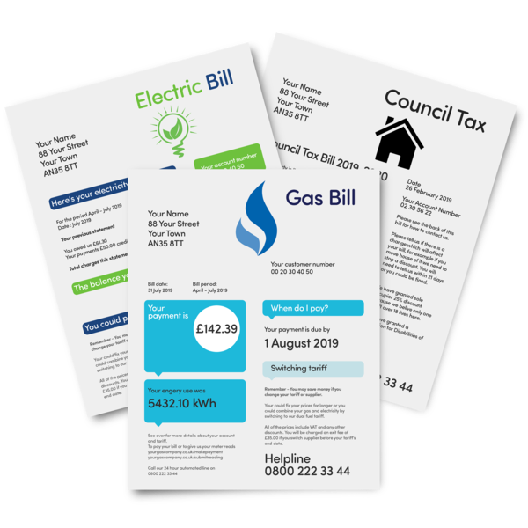gas
* water.

We also cannot pay out claims for **compensation**.

**Compensation** is money paid out to someone to:

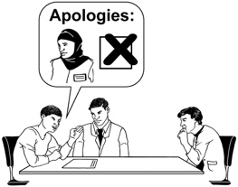make up for something bad that happened

say sorry.

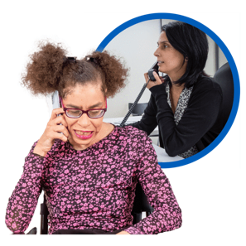

If you do not know who you should talk to about a telecommunications complaint you can talk to us.

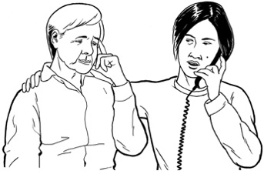

We can then tell you who you need to talk to.

# How will TDR assist you?

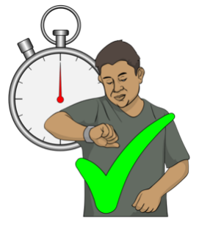

We try to assist people as soon as possible.

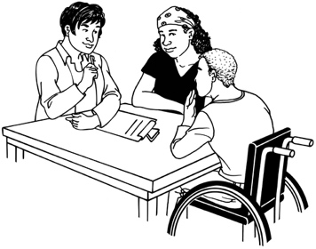First we tell your telecommunications provider about your complaint so that we can work together on it.



We can often fix complaints at this step.

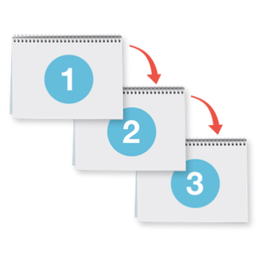

If a complaint needs more work to find a good outcome for you there are some more steps we can use.



We can be the **mediator** in a talk between you and your telecommunications provider.

A **mediator** is someone who is in the middle to assist two groups to:

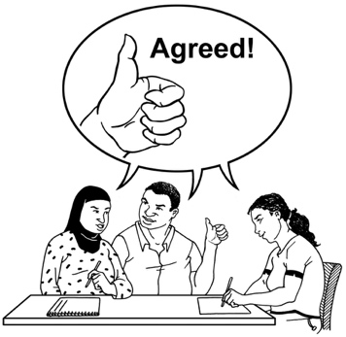talk to each other

come to an agreement.

If you still cannot agree with your telecommunications provider about your complaint TDR can:

make a decision about what your telecommunications provider should do

tell them what to do

tell you what your part in the solution is.

# How to contact TDR

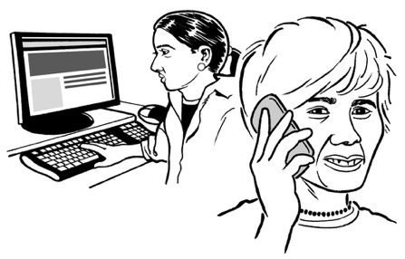

If you want our assistance please contact us.



You can **phone** us at this number:

**0508 98 98 98**



You can **email** us at this address:

[**contact@tdr.org.nz**](mailto:contact@tdr.org.nz)



You can find more information about how to contact us at our **website**:

[**www.tdr.org.nz**](http://www.tdr.org.nz)

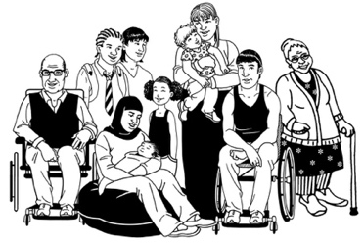We do our best to make it easy for everyone to get assistance from us.

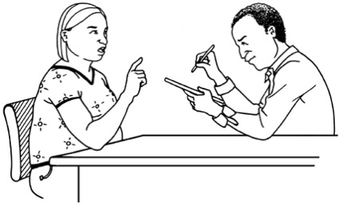

If you have any special requirements please let us know.



Throughout the complaints process we will:

guide you

support you.



If you find it hard to use the phone the **New Zealand Relay** service is for people who are:

* 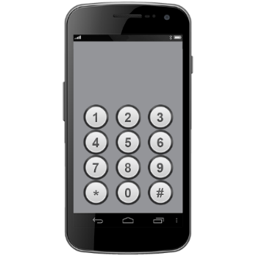Deaf / hard of hearing
* deafblind
* speech impaired / find it hard to talk.

You can find out more about the New Zealand Relay service at:

**www.nzrelay.co.nz**

# Where to find more information



You can find more information about us at our website:

[**www.tdr.org.nz**](http://www.tdr.org.nz)



This website is not in Easy Read.



We have a list of questions we get asked a lot on this **website** page:

[**www.tdr.org.nz/resources/faq**](http://www.tdr.org.nz/resources/faq)



If you have any more questions please contact us.

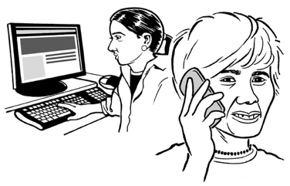

Our contact details are on **page 18.**

This information has been written by Telecommunications Dispute Resolution.

It has been translated into Easy Read by the Make it Easy Kia Māmā Mai service of People First New Zealand Ngā Tāngata Tuatahi.



The ideas in this document are not the ideas of People First New Zealand Ngā Tāngata Tuatahi.

Make it Easy uses images from:

* Photo SymbolsChangepeople.org

Photosymbols.com

* SGC Image Works
* Huriana Kopeke-Te Aho
* T. Wood.

  
All images used in this Easy Read document are subject to copyright rules and cannot be used without permission.